|  |  |  |
| --- | --- | --- |
|  | **Rochester Institute of Technology**  **Golisano College of Computing and Information Sciences**  **School of Interactive Games and Media**  **2145 Golisano Hall – (585) 475-7680** |  |

**Data Structures & Algorithms for Games & Simulation II**

**IGME 309**

**E05: Transformations**

This exercise follows lecture 06B - Transformations

It is meant to help you practice creating a new OpenGL project from scratch in Visual Studio and use glm library’s transformation methods.

There is no starter code for this project but a great place to start would be from “C10_MeshClass” or “C11_TranslationAndScale”

This exercise is broken in 2 parts, the first one is to replicate the scene portrayed in the following picture using only the glm::translate and glm::scale methods and the MyMesh class we have been programing.

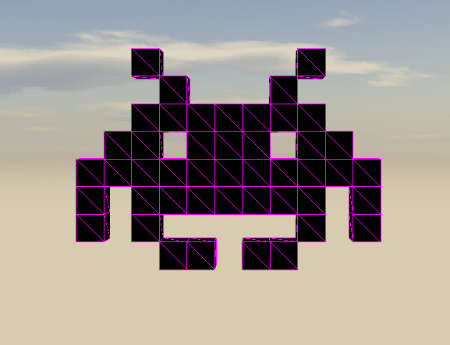

The second part of the exercise is to make all of the cubes move together from left to right of the screen.

There is no particular value that you need to follow or any particular data structure to use in order to store the MyMesh objects, but std::vector is a great place to start looking. Make sure that you deallocate all the MyMesh objects and that you are not recreating them each frame!

In the repository for the class there is a demo of this exercise. In my example, the Invader is moving in a sine wave, that is just so it doesn’t move so flat, if you wish to you can add it, but for the sake of the grade having it move from left to right is more than enough. Speaking about the grade 5 points go for creating the shape as in the image, and 5 points to make it move.

Notes:

Drawing primitive by primitive is really wasteful as we are calling the graphics card for each shape, a cleverer way to do this is though instance rendering, but we have not cover that, we will be revisiting this exercise once we cover said topic.

As usual, your submission is only a zipped version of the project NOT the whole solution, it should be less than 50 kb total, (unless you are using your own models/textures or your own framework solution). Push your solution to your repository with the comment “**E05 Deliverable**” then zip the project and upload it to the dropbox, in the comments section you need to specify the address of your repository. Example:

